NAME:Rishik JK
REG.NO :192511052

CSA1702-ARTIFICIAL INTELLIGENCE
LAB EXPERIMENT

21. Prolog Program to Implement Towers of Hanoi

1. Aim
To write a Prolog program to solve the Towers of Hanoi problem using recursion.

2. Algorithm
- Start the program.
- If there is only one disk, move it from source to destination.
- Move the remaining N-1 disks from source to auxiliary.
- Move the largest disk from source to destination.
- Move the N-1disks from auxiliary to destination.
- Stop.
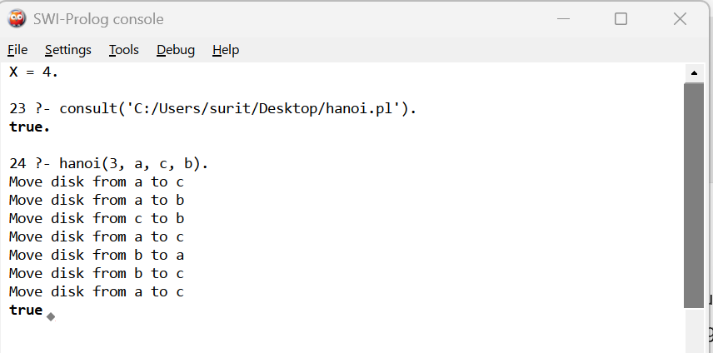

3. Result
Thus, the Prolog program to implement the Towers of Hanoi problem using recursion was successfully implemented and executed. The disks were moved from the source peg to the destination peg using the auxiliary peg.

